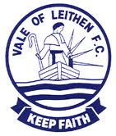 |  |  | victoria Park  HALL STREET  innerleithen  EH44 6RF  a Park  contact us  Phone 07500979591 Michael Hogarth  Email: Michael1746@hotmail.com  www.valeofleithen.co.uk

VALE OF LEITHEN FOOTBALL CLUB

SPONSORSHIP BROCHURE

MATCH SPONSORSHIP  • Sponsor and three guests are invited to sponsored match  • Pre-match drinks served in the boardroom  • Drinks and snacks are served in the boardroom at half-time  • Sponsor choice of Player of the Match Award  • Full-time drinks are served in the boardroom  • Pre-match advertising in the town  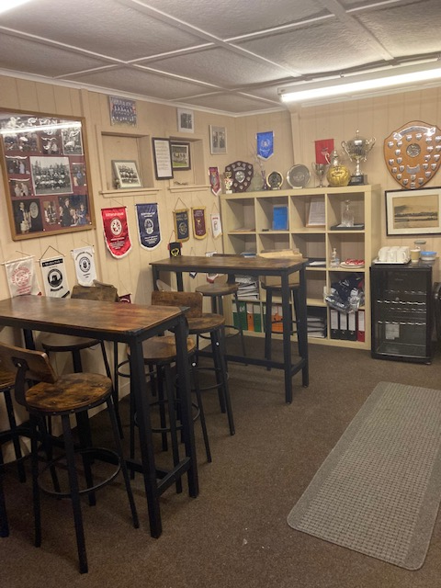  PLAYING KIT SPONSORSHIP  - The company logo displayed on the shirt for the full season.  - The company name will appear in the match day programme for every home game  - Pitch side advertising  - Direct link to your company on the club’s website.  - Invite for 2 people to a match during the season and enjoy the club’s hospitality  • £1000 per season |  | • Pre-match day advertising at the ground  • Acknowledgement and complimentary advertising in the programme for the full season, including high profile friendlies  • Acknowledgement and web link (where applicable) on the website for the full season  • Acknowledgement on the Club Facebook Page and Group, plus adverts where applicable  • Sponsors given priority to purchase tickets for social events, such as Sportsman’s Dinner, throughout the year  • A guest invitation to the end of season Players of the Year Awards  £150.00  FULL SEASON MATCH BALL SPONSORSHIP  - Sponsors will receive the same hospitality and advertising as the Match Sponsor  - Acknowledgement and complimentary advertising in the programme for the full season, including high profile friendlies  - Acknowledgement and web link (where applicable) on the website for the full season  - Acknowledgement on Club Facebook Page and Group, plus adverts where required  - Sponsors given priority to purchase tickets for social events, such as Sportsman’s Dinner, throughout the year  - A guest invitation to the end of season Players of the Year Awards  £600 per season

ball sponsor
- Sponsor the match ball for £50. Individuals or companies will be advertised on our website and Facebook Page and will be advertised on match programmes (if issued) and Match Posters.
- One person will also receive free entry to the match, a hospitality drink before the match and hospitality food and drinks at half-time. Additional guests can also be arranged for a small fee.
- A photo of the sponsor with a player will also be taken for the webpage.
- Contact any of the Committee or use the 'Contact US' link above for more details.

£50.00

PLAYER AND COACH SPONSORSHIP

Player sponsorship costs £50 per season for Home kit and £30 per season for Away kit, and
is open to any business or individual. This sum does not cover, but contributes to the cost of training kit,
treatment of injuries, general expenses etc.
Player sponsors will receive:
• acknowledgement in the match programme, Facebook Page/Group and website (web link where applicable) for the full season.
• multiple sponsorships can be supplied at reduced rates, e.g., joint home and away £65
PITCH SIDE ADVERTISING
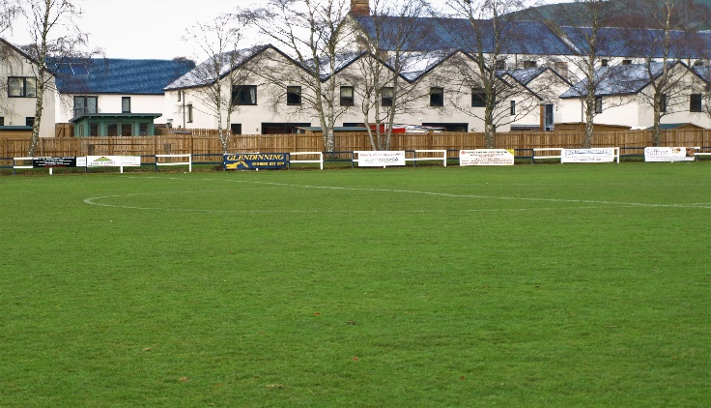
• Displayed at every home game during full season
• The initial production cost is £90 (8’ x 2’ Plastic Banner); businesses may supply their own . banner.
• The annual maintenance charge and season display is £50.
• Acknowledgement in the match programme and website.
• The estimated life expectancy of a banner is five years.

WEBSITE AND FACEBOOK ADVERTISING
- Based on the size of the advert a cost ranging from £50-£90 to include a full season advertising on the website and Facebook, plus programmes when issued

